**Setting up the ETRM Automation Framework**

1. Navigate to the shared drive below

\\a0028-fil0005-s\Team_AOS_Automation\ETRM_QC_Framework

1. Copy the files listed below from the network to a location on your local machine. Eg C:\Automation. Ensure that it is on your C drive no the network H drive

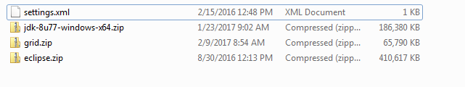

1. When the files have been successfully copied across to your local machine right click on each folder and select Extract All

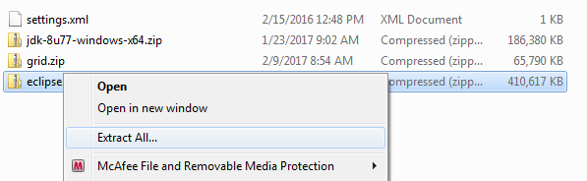

1. On the dialog window that opens click the extract button

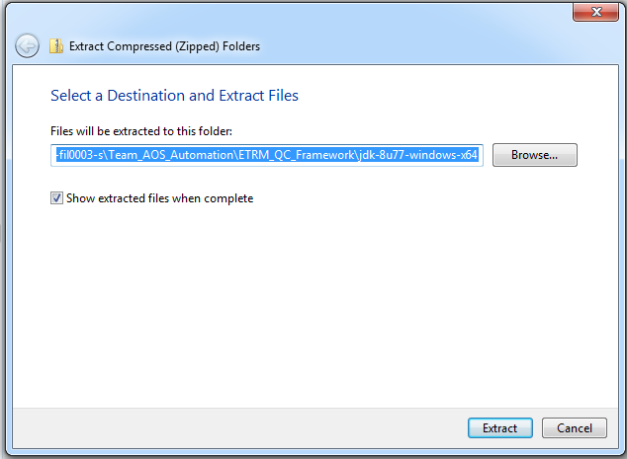

Allow the extraction of each file to complete.

1. When all 3 files have been extracted you should files/folders listed below.

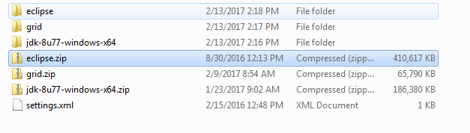

1. Open the eclipse folder and the eclipse folder within that and launch the eclipse.exe file

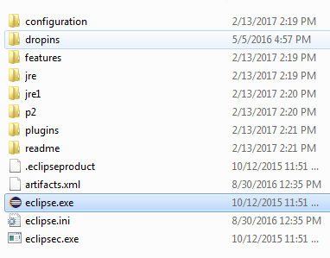

1. You may see a warning message that a workspace cannot be opened for PORO. Change this manually to a path on your C driver. If the Welcome/Start panel is displayed it can be closed. when complete Eclipse IDE should be displayed See below

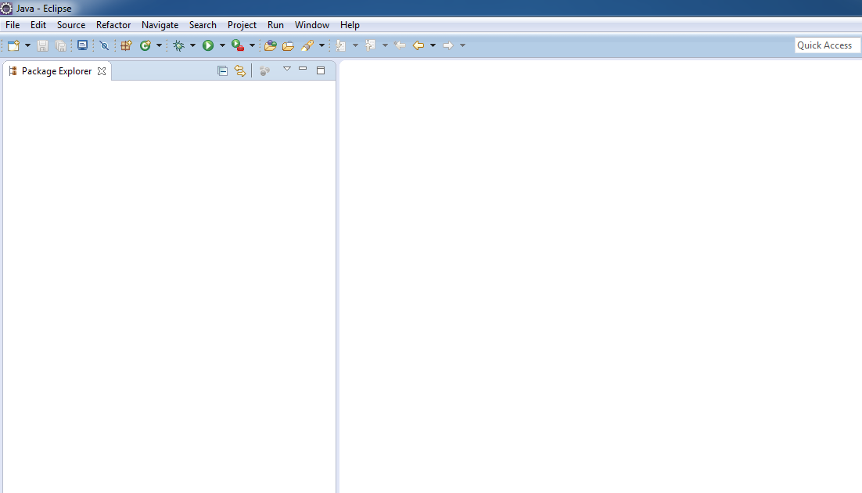

1. Click on Window🡪 Preferences and you will have the dialog below displayed

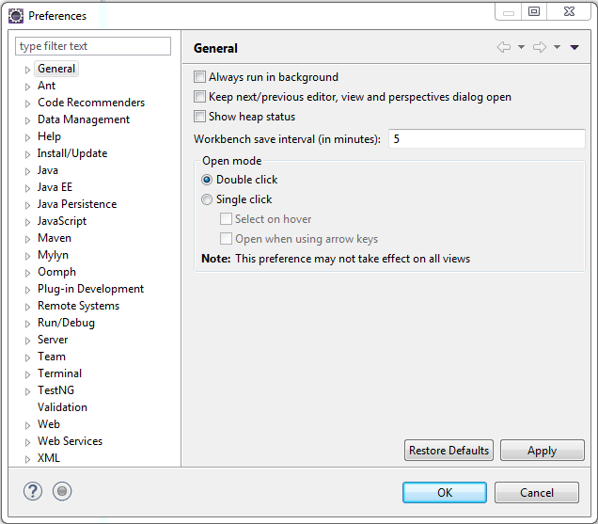

1. Expand the Java preference and Select Installed JRE’s. The dialog below will be displayed

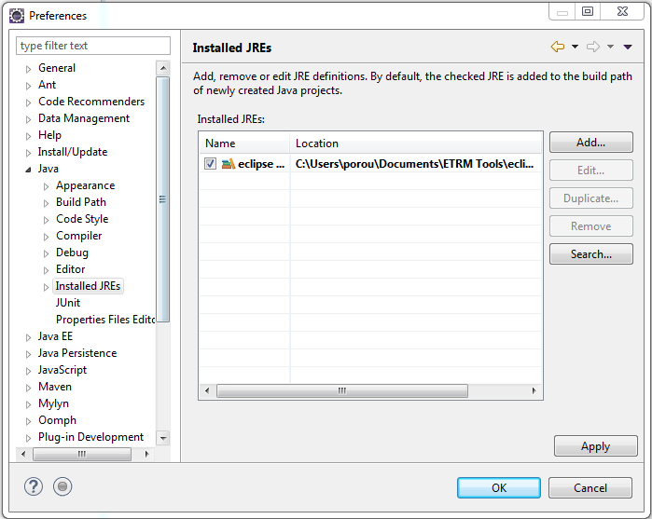

1. Click the Add Button and select Standard VM on the popup window below

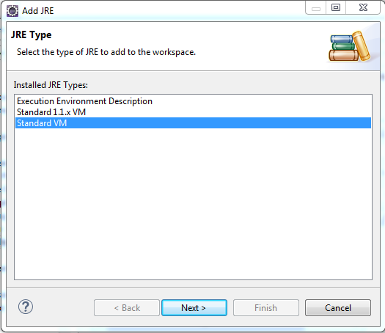

Then click next

1. The window below will be displayed.

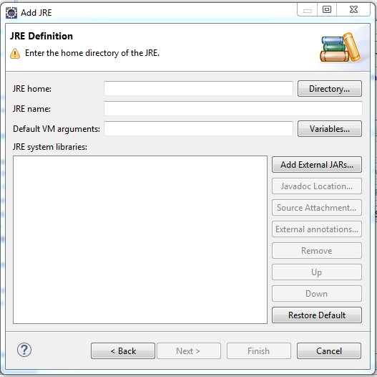

Click the Directory button.

1. Navigate to the directory where you have extracted all the files and select the tools folder from within the folder jdk-8u77-windows-x64\jdk-8u77-windows-x64. Then click ok

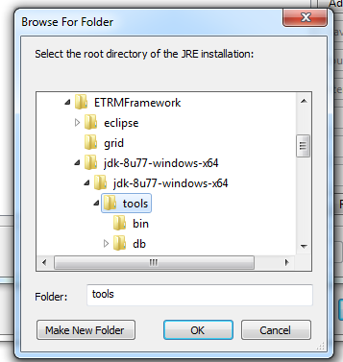

The JRE System libraries section should now be populated. See below

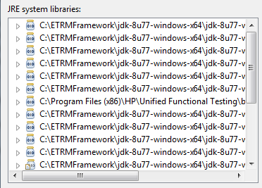

Click Finish

1. There should be 2 installed JRE’s eclipse( Default) and tools. Untick eclipse and tick tools as below.

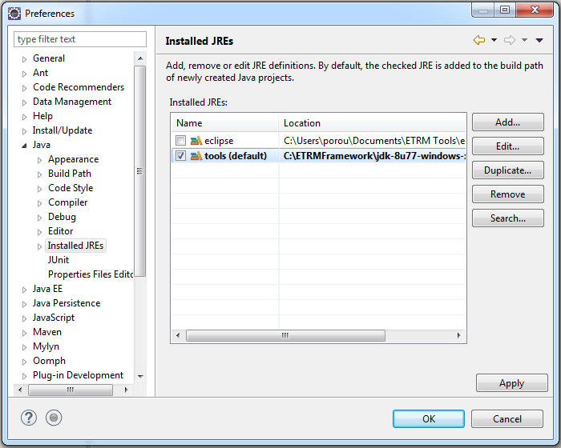

Click OK

1. To Clone down the ETRM Automation framework follow the steps in the document Clone GitHub1.docx. This is in the folder you have copied from the network drive.
2. Whenever the clone process has completed. Right click on the AS-Testdriver project and select Build Path🡪Configure Buildpath. Click on the libraries tab

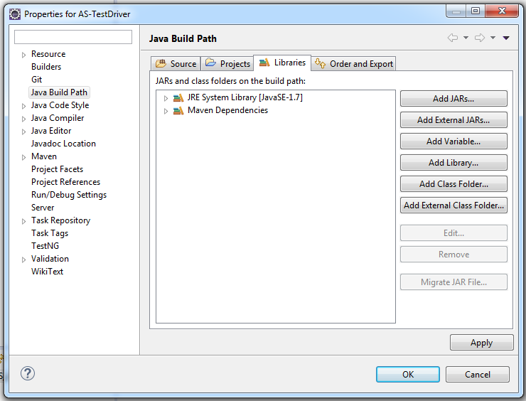

Click Add Library

1. Select the JRE System Library and click Next

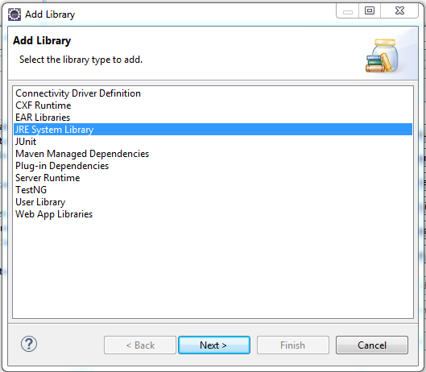

1. Ensure Workspace default JRE is selected.

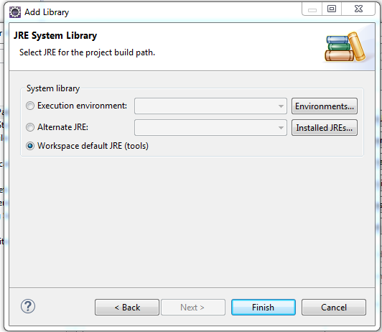

Click Finish

1. Select the JRE System Library [JavaSE-1.7] and click the remove button

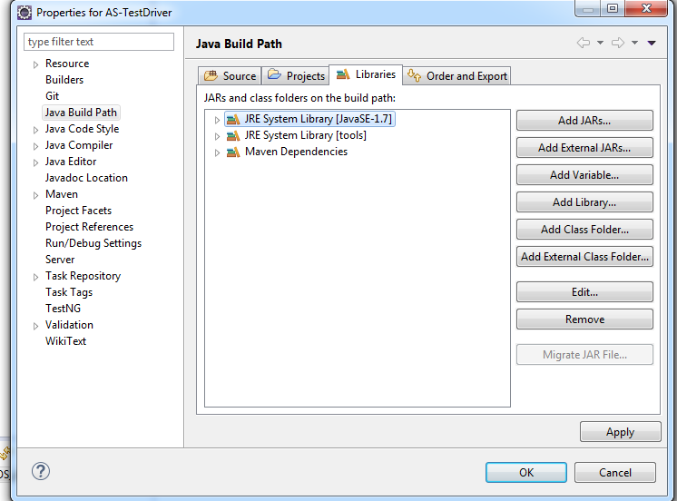

Click Apply and then OK